STEP BY STEP APPROACH OF MY Mobile-Lab2 Android Application

**# PART 1: STEP COUNTER**

Following are the screenshots of my Step Counter Application,

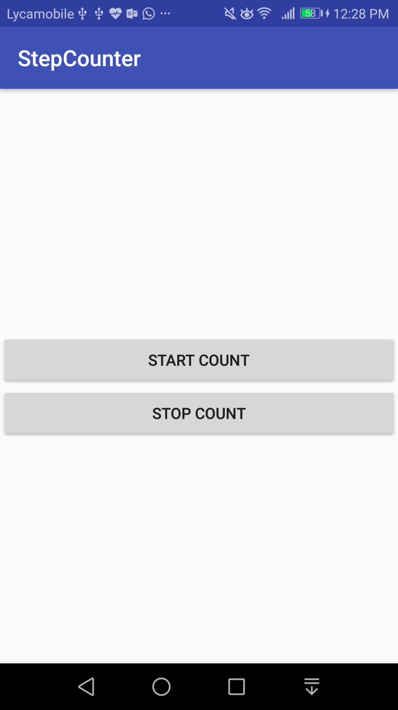 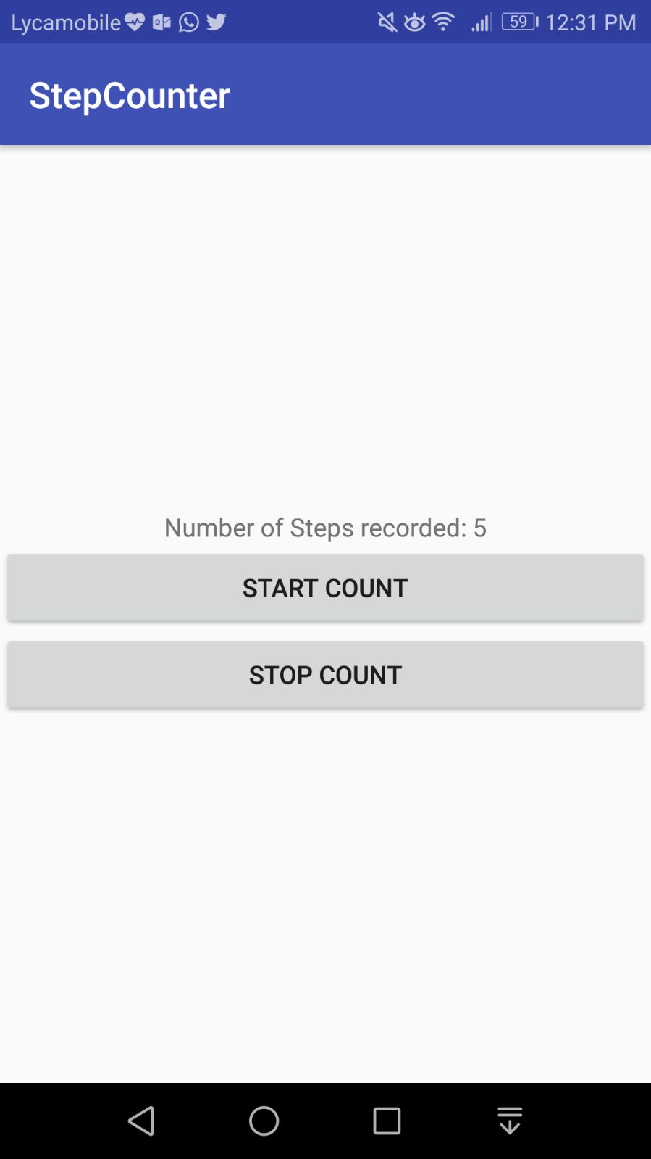

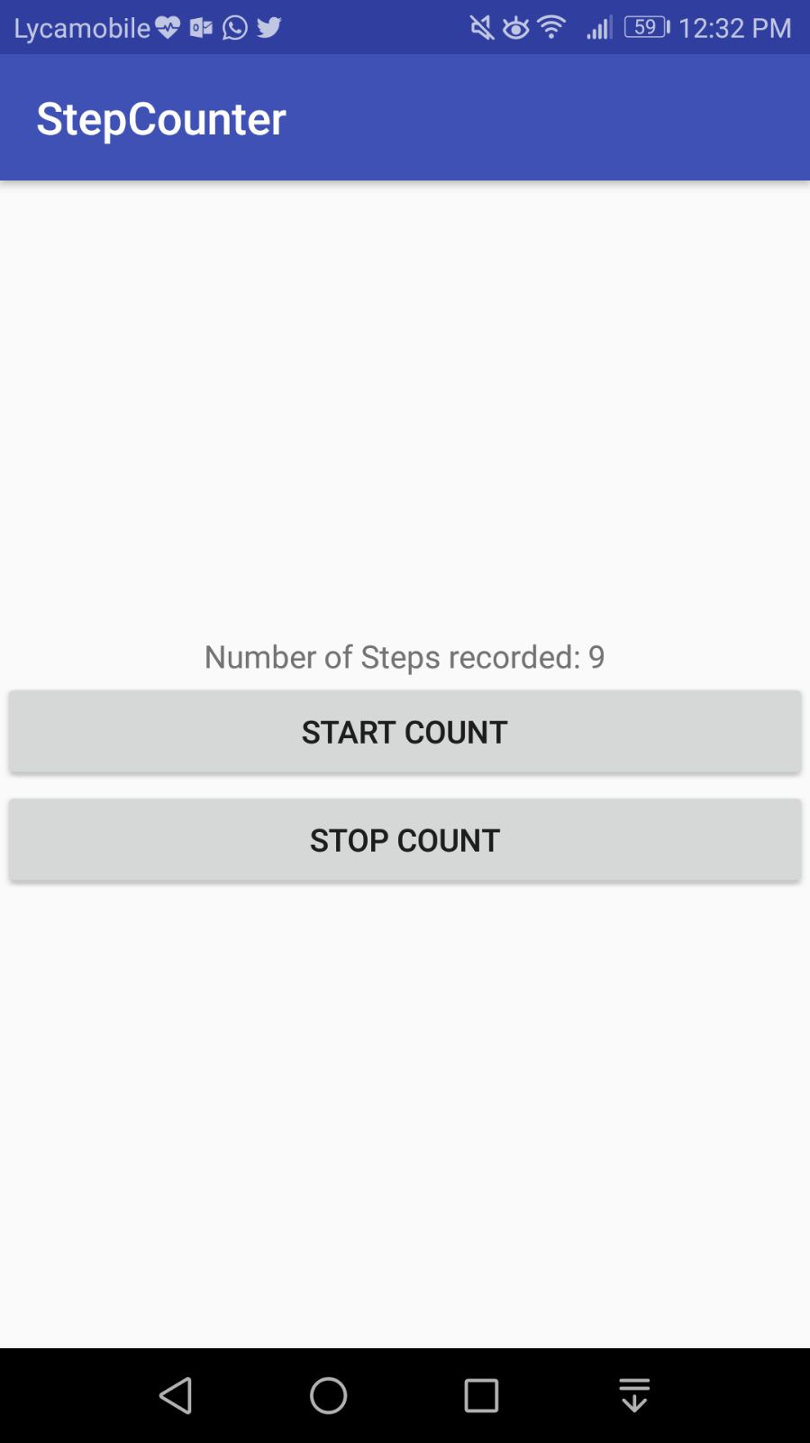 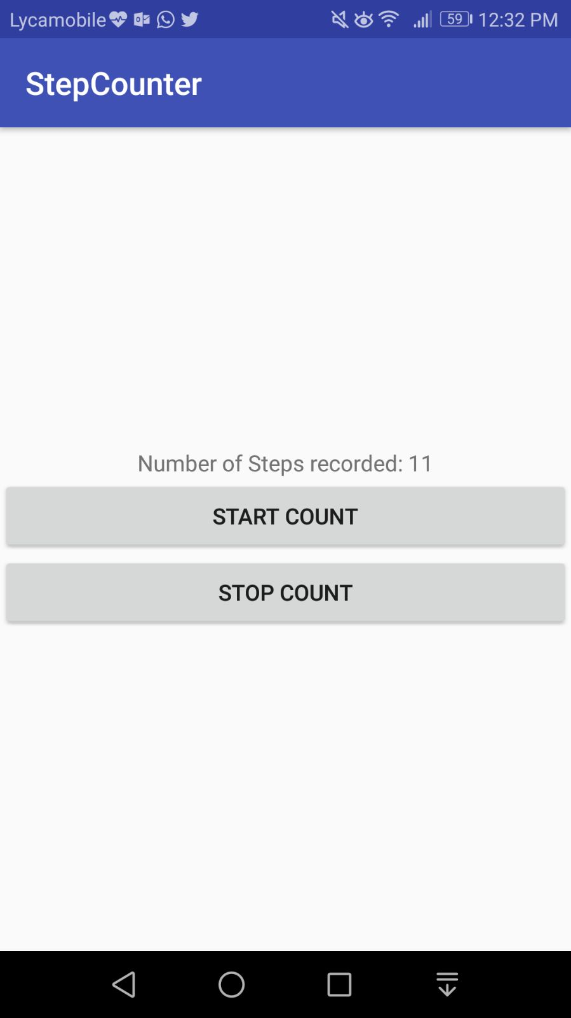

Following is the picture of my java code:

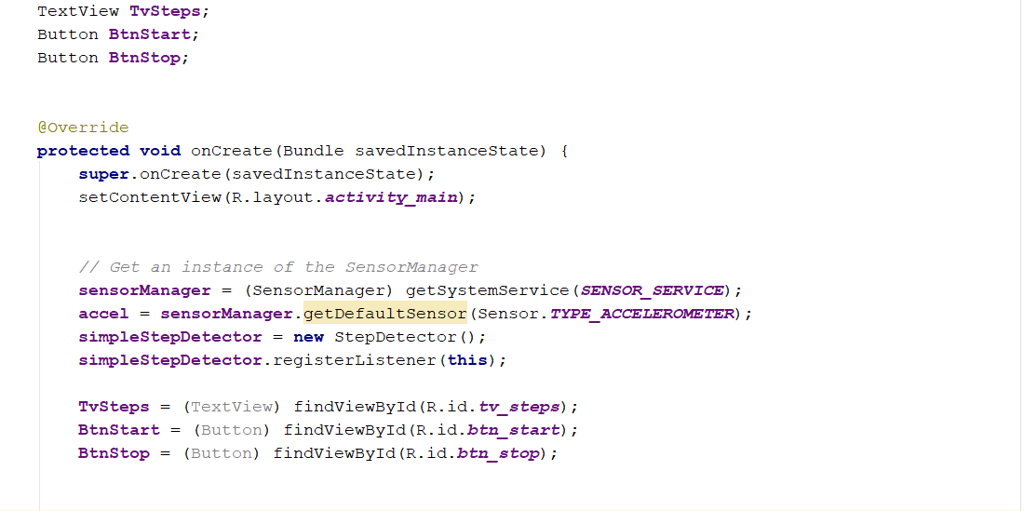

**# PART 2: FACE DETECTION**

Following is the screenshot of my Face detection application

* User can choose a picture from gallery

* User can scan images using Camera

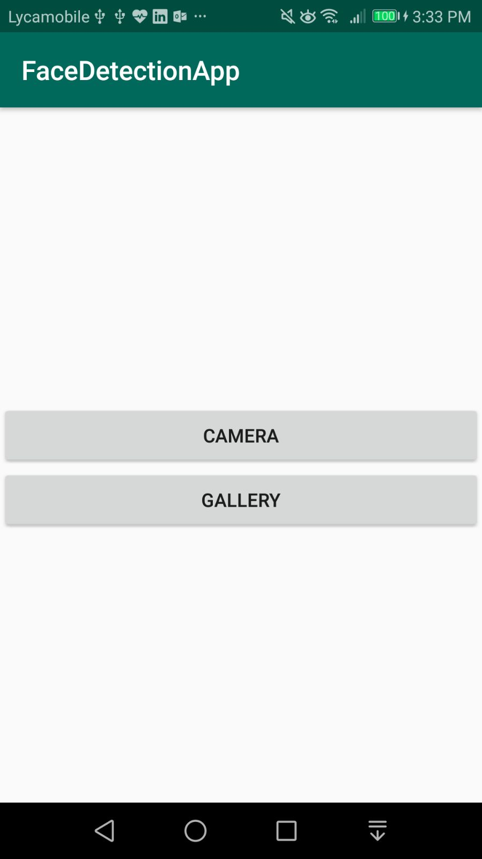

# If User selects "Gallery" option:

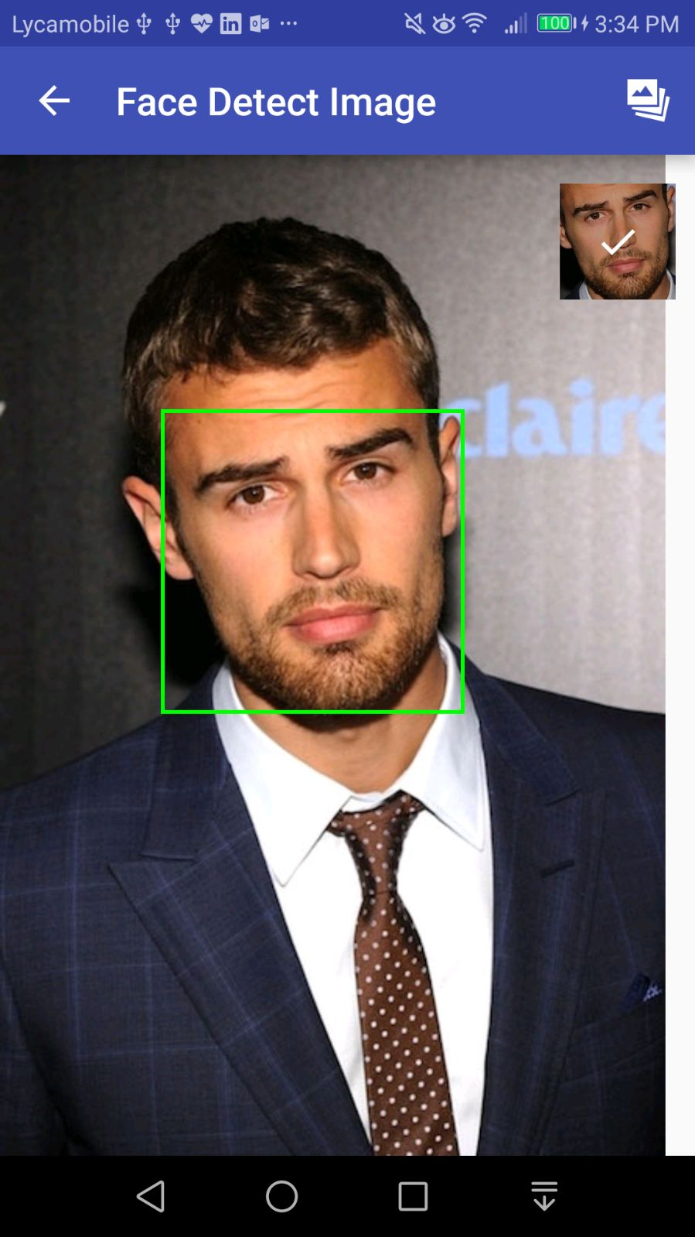

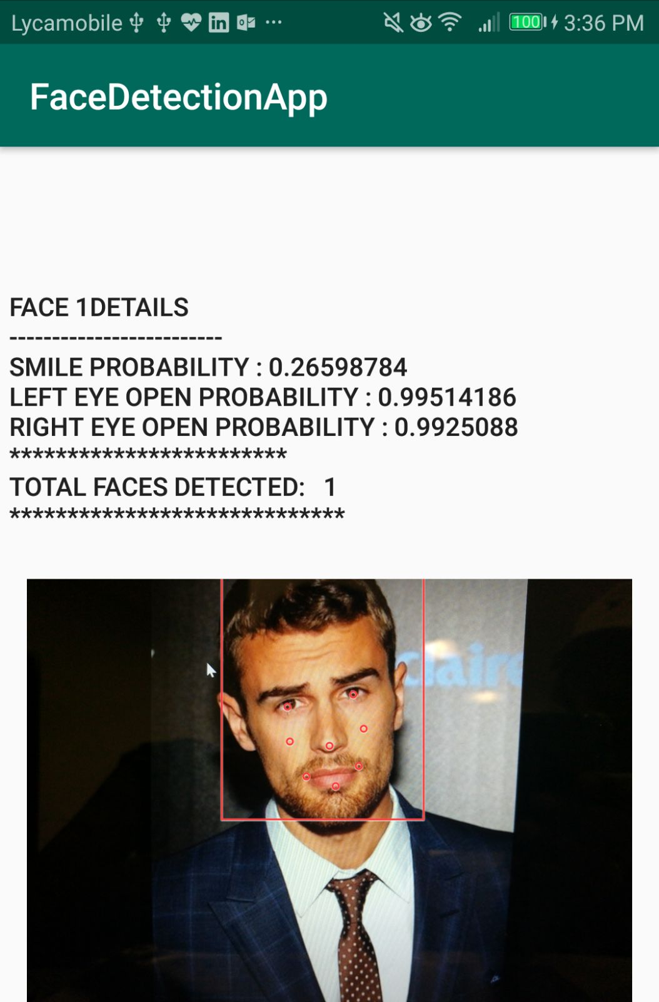 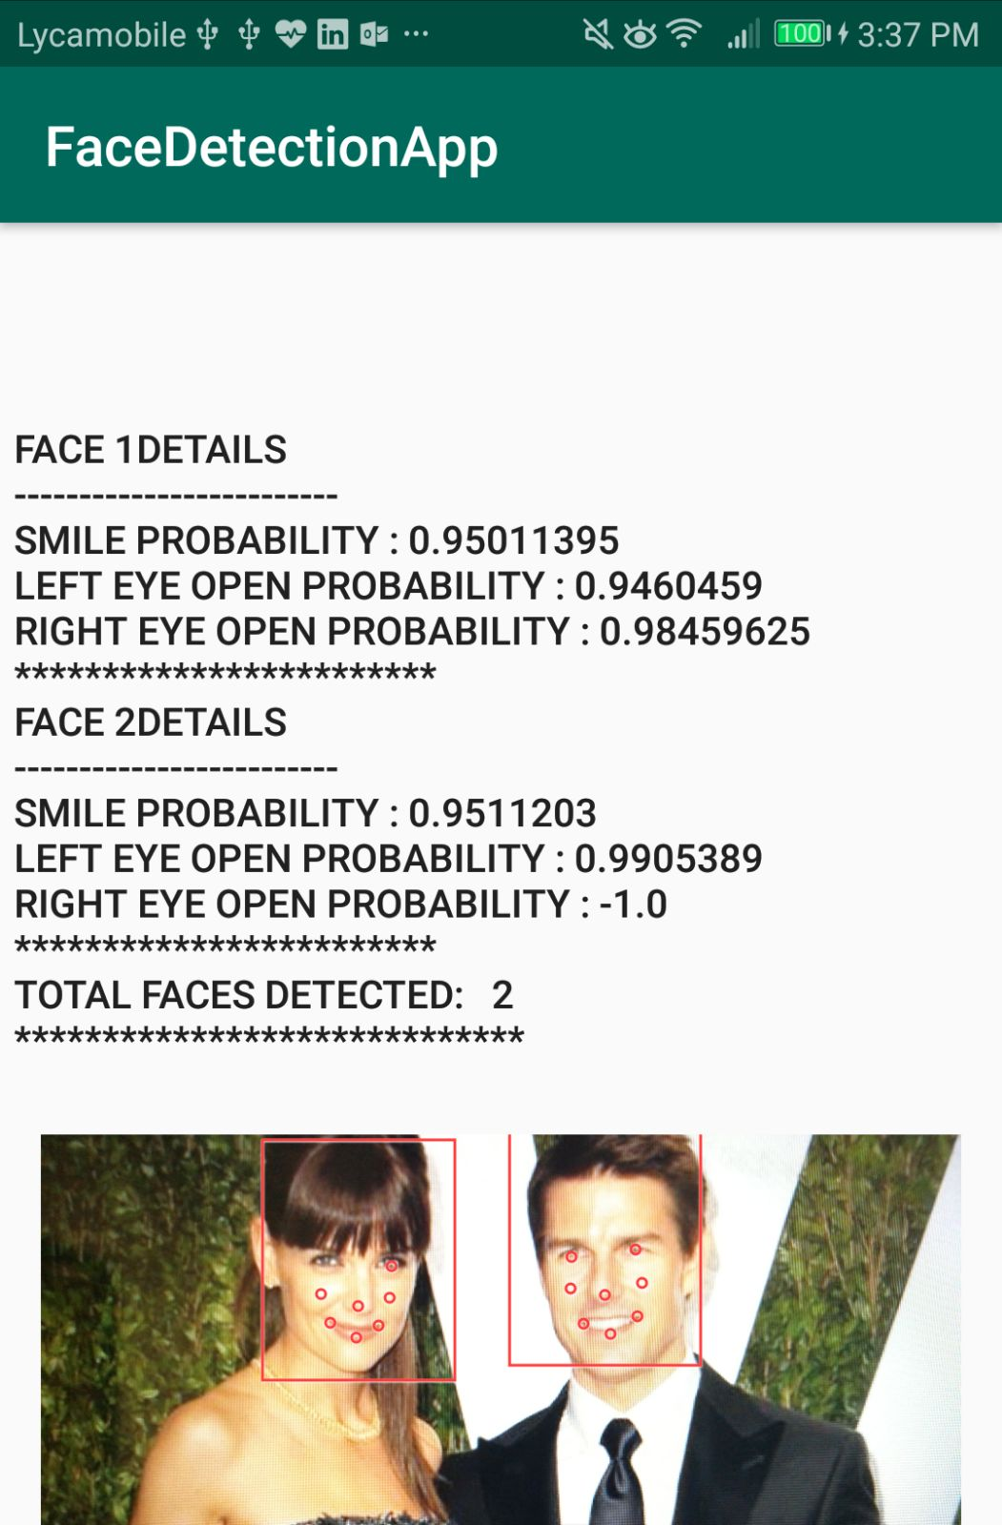

# If User selects "Gallery" option:

Following is the link to a video of my app:

<https://github.com/snehadidigam/Web-Cloud-Mobile-Programming-Assignmets/blob/master/MobileAssignment2/documentation/FaceDetect/WhatsApp%20Video%202018-04-25%20at%204.36.52%20PM.mp4>

Following are the screenshots of my camera option scanned images:

